***SULIMMO MARKING SCHEME***

***BUSINESS STUDIES PAPER 1***

1. **Define the following terms: (4 marks)**
2. **Scarcity**

Less than required situation where resources are limited in supply hence not sufficient to satisfy human wants.

1. **Opportunity cost**

* The cost of the best alternative which is chosen
* The alternative which you forgo when you spend time and money on one thing and defer spending it on another
* The cost of what has to be forgone in order to enjoy another product

1. **Scale of preference.**

This refers to a list of unsatisfied wants arranged in order of priority

d)**Choice**

Selection of best alternative from among many. Human beings have to select the best way of using the scarce resources to satisfy as many wants as to possible/select which wants to satisfy first.

1. **Highlight four circumstances under which a manufacturer would not require a lot warehousing facilities. (4 marks)**
2. **Outline four features of labor as a factor of production. (4 marks)**
3. Labor is a human resource with the ability to think and get annoyed
4. Labor cannot be stored for future use/labor is perishable, hence idle labor is wasted
5. It cannot be separated from the provider/laborer since it is a service
6. Labour is highly mobile geographically hence can be moved from one region to another
7. Labour is highly mobile occupationally hence can be applied from one task to another
8. The productivity /quality of labour can be improved through education, training, experience, adequate rewards etc
9. Providers sell the labour not themselves for a price
10. The quality of labour can be standardized i.e it varies from one provider to another
11. It is a basic factor of production
12. **Highlight four benefits of using mobile money transfer services as means of payment. (4 marks)**
13. Confidentiality-The secret PIN protects the value in the customer’s account
14. Ease of use-The service is easy to use as the agents assists to carry out transaction
15. Speed-Money transfer is an instant service conveyed to the receiver via the short message service(SMS)
16. Convenience-The service is convenient to both the sender and the receiver, as they only need to go to the nearest agent(money can be sent/deposited or received anywhere)
17. Accessibility-The agents e.g. m-pesa agents are located in most parts of towns and also in rural areas. Money can hence be sent and received anywhere and anytime.
18. Affordability-The service charges are very low for registered users and very affordable for non-registered users
19. Security-Relatively secure when the sender uses the correct phone number of the receiver.
20. **State the source document and journal that deals with each of the following types of transactions. State the journal that deals with each of the following types of transaction: (4 Mks)**

|  |  |  |  |
| --- | --- | --- | --- |
|  | TYPE OF TRANSACTION | **SOURCE DOCUMENT** | **JOURNAL** |
| I | Credit Sales. | ***Sales invoice*** | ***Sales journal*** |
| Ii | Returns of goods by customers. | ***Credit note issued*** | ***Sales returns journal*** |
| Iii | Credit purchases. | ***Purchases invoice*** | ***Purchases journal*** |
| Iv | Return of goods to suppliers. | ***Credit note received*** | ***Purchases returns journal*** |

**(4 marks)**

1. **State four benefits associated with the construction of the Standard Gauge Railway ( SGR ) to the Kenyan economy. (4mks)**
2. It promotes the development of industries by facilitating the movement of raw materials and distributing finished goods
3. Promotes the development of agriculture by transporting inputs to farmers and produced goods to the market
4. Promotes regional specialisation by transporting the goods produced to the market thereby encouraging the continued production of such goods
5. Facilitates the delocalisation of industries hence creating job opportunitie in the counties.
6. Facilitates the movement of workers and business people from one place to another
7. Promotes the movement of people within the country creating peace and understanding
8. Facilitates the disposal of surplus goods hence avoiding wastage
9. Promotes tourism by transporting tourists to tourist attraction sites
10. **Highlight four channels of distributing locally manufactured products in foreign markets. (4mks)**
11. Local manufacturer → Foreign consumer.
12. Local manufacturer → Foreign Retailer → Foreign Consumer.
13. Local manufacturer → Local Wholesaler → Foreign retailer→ Foreign Consumer.
14. Local Manufacturer →Local Export Agent→ Foreign Retailer→ Foreign Consumer.
15. Local Manufacturer→ Local Export Agent→ Foreign wholesaler →Foreign Retailer→ Foreign Consumer.
16. Local manufacturer→ Co-operative society → Foreign Consumer***.***
17. **The following details were extracted from the Books of Simsim for the year ended 30th April 2006.**

**Capital as at 30th April 2006 sh. 720, 000**

**Drawings for the year sh. 50, 000**

**Additional investments sh. 340, 000**

**Profit sh. 80, 000**

**Determine Simsim’s capital on May 2005**

Final capital= initial capital +additional investment+ net profit-loss-drawings

720,000= X+340,000+80,000-50,000

Initial capital= 350,000

1. **On May 1st 2023 the cash of Masomo Traders showed cash and bank balances of Sh, 15,000 and Sh. 147,000 respectively. Transactions that took place during the month were as follows:(4 mks)**

**May 3: cash sales Sh. 120,000.**

**May 11: paid sh.7,500 cash in respect of wages**

**May 16: received a cheque of sh. 250,000 from a debtor**

**May 26: withdrew sh.250,000 from bank for office use**

**May 29: paid sh.97,000 cash to a creditor**

(please work it out)

1. **The National income is measured using the expenditure approach as Y = C + I + G +(X - M). State what each of the following letter represents. (4** marks)

C- Expenditure on consumer goods/ on consumption.

I: Expenditure on capital goods/ on investment.

G: Government Expenditure.

(X-M) -Expenditure on net export/ on net factor income from abroad

1. **State four documents used in home trade under inquiry stage. (4 marks)**
2. Letter of inquiry
3. Quotation
4. Catalogue
5. Price list
6. **Kuria is a small-scale retailer. Outline four considerations he needs to make before he advances good’s on credit to Kamau his friend (4 mks)**
7. The amount of stock available.
8. The frequency of the customer to the seller.
9. The creditworthiness of the customer.
10. The repayment period.
11. Amount of goods to be sold on credit
12. Honesty and reliability of the buyer
13. The objectives or intentions of the seller
14. Prevailing economic conditions
15. Credit period
16. Accessibility of the customer
17. Type of collateral security/guarantee provided by the customer.
18. **Situma insured his maisonette worth sh. 800,000 for sh. 700,000 and unfortunately the house was destroyed by an inferno and he sustained losses worth sh. 600,000. Calculate the amount of money that Situma should claim from the insurance company as compensation and comment. (4 marks)**

*Compensation =* 

*Compensation =* 



*This is because he under insured his house.*

1. **Outline four characteristics of a good entrepreneur. (4 marks**)
2. Desire to achieve
3. Ability to solve problems
4. Ready to take risks
5. Initiative
6. Time consciousness
7. Creativity and innovation
8. Independence
9. Self confidence
10. Persistence and patience
11. Seek information
12. Concern for high quality products
13. Commitment to work
14. Concern for customer satisfaction
15. Desire for feedback
16. **Moi Girls School Nairobi trustees would like to build a new administration staff offices. Outline four reasons why you would advise them to establish an enclosed office layout.(4 marks)**
17. There is privacy for confidential discussions.
18. There is less noise and disruption from workers and machines
19. It Provides a conducive working environment
20. Retains the status of senior employees/ confers status to senior employees.
21. Prevents spread of contagious diseases such as TB & COVID-19.
22. The occupant can control air conditioning, lighting and heating in the room.
23. Ensures security for valuable and sensitive items.
24. **Outline four reasons why a business organization may decide to amalgamate. (4 marks**)
25. Where there is continuous decline in profitability
26. Where they intend to venture into a new line of production
27. Where there is need to expand capital base
28. Where there is need to bring on board new skills
29. Where there is need to share research information
30. Where there is need to control output and sell it at a high price
31. Where there is need to control a wider market to increase sales
32. Where there is need to lower the cost of raw materials
33. **Highlight four circumstances under which downward communication would be appropriate in an organization. (4 marks)**
34. When Training juniors
35. When evaluating performance of juniors
36. When Delegating duties to juniors
37. When Solving problems facing junior officers
38. When Inspiring and motivating juniors.
39. **Kenya is the main exporter of tea in the international market. State four ways in which the government of Kenya may increase the export volume of the tea.(4mks)**
40. Establishing Export Processing Zones (EPZ)
41. Devaluing the local currency.
42. Increasing/raising the quotas.
43. Lowering export duty.
44. Providing subsidies to farmers/ producers.
45. **State whether the following factors causes a shift in demand or supply (4mks)**

|  |  |  |
| --- | --- | --- |
|  | **Statement** | **Demand/ supply** |
| A) | Changes in consumers income | Demand |
| B) | Cost of production | Supply |
| C) | Changes in technology | Supply |
| D) | Seasonal changes | Supply |

**20. Study the figure below and answer questions that follow.** 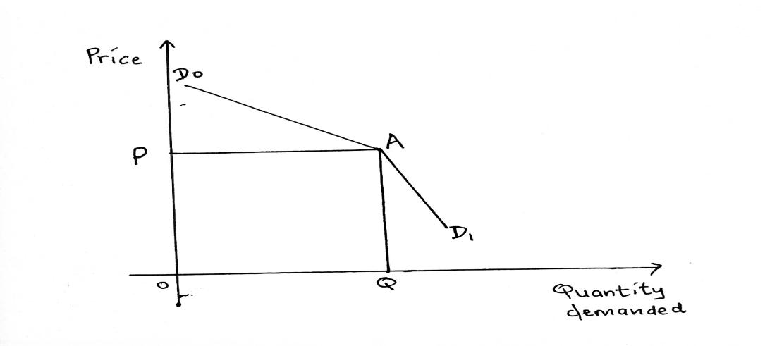

(a) Name the curve above. (1 mks) **kinked demand curve**

(b) State the market structure that experiences this kind if demand curve. (1 mk) **oligopoly**

(c) What P represent in the curve above?( 1mk) **price**

(d) State one reason why a demand reduces when prices are increased above P. (1mk)

1. **Identify four challenges that a country with high population of ‘’Gen-Zs’’ is likely to face. (4marks)**
2. High rate of unemployment as demand for jobs outstrips the available
3. Rate of crime/social evils may rise as the youth remain idle, they are likely to resort to crime and other social evils as they look for means of survival
4. Dependency ratio will rise as economically active population will shoulder a bigger economic burden
5. Constraints on goods and services associated with young people as demand outstrips supply/due to increase in demand
6. Reduced savings and investments. Investments will decline as aresult of high rate of consumption by young people. This may lead to low development
7. Low per capita income. Since the national income will be spread over non-contributing population which may lead to a low standard of living
8. Problem of raising government revenue
9. Low labour supply
10. **Mention four levels of inflation that a country may experience. (4 marks)**
11. Hyper inflation/runaway
12. Galloping /rapid inflation
13. Stagflation
14. Greeping/mild/moderate inflation
15. **Highlight four factors that are likely to hinder development in the third world countries. (4 mar**ks)
16. Inaccessible to/lack of appropriate technology
17. Poor development planning/resource management
18. Shortage/inadequate skilled labour
19. Shortages/inadequate natural resource endowment
20. Brain drain-skilled manpower seeking greener pastures elsewhere
21. Low demand for goods/services/limited markets
22. Limited entrepreneurial skill/ability/culture
23. Inadequate/lack of foreign exchange which limits access to imports /negatively affecting consumption
24. Poor infrastructure
25. Poor governance /corruption due to lack of accountability

24**. State the business environment described below.**

**Description**

1. Business culture **internal**
2. Affect buyer’s purchasing power. **External**

(c) Methods used in production of goods and services**. Internal**

(d) Formal organization of activities for achievement of goals. **External**

25**. Outline four factors that may make a firm find it necessary to carry out its operations near the source of raw materials. (4 marks)**

1. Cheaper transportation of raw materials
2. Ease of handling bulky raw materials
3. When dealing with highly perishable raw materials
4. If the government policy requires the firm to be located near source of raw materials
5. Fragile raw materials